Weekly Up-date
March 19, 2026
First Presbyterian Church of Washington website:
www.washingtonfpc.org
New or updated announcements are highlighted.
Sunday Worship 10:30 am

UPCOMING EVENTS & OTHER HAPPENINGS…
USHERS: Ian Allen, Gabe Ullrich and Jim Vlossak.

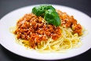
SPAGHETTI DINNER: TICKETS STILL AVAILABLE The Chancel and Carillonaires Choirs will be hosting a Spaghetti Dinner on Saturday, March 21, 2026. See Flyer in the back. Tickets will be sold in coffee room after church and during the week in the church office.
EASTER FLOWERS SALE: See Flyer Below. LAST DAY TO TURN IN FORMS IS THIS SUNDAY MARCH 22,2026.
CLOTHING SHED: Great news. We have a brand-new clothing shed at the far end of the side parking lot. Gather your unwanted wardrobe and donate it in our shed to help raise money for our church. It’s time to switch over your closets with your winter wardrobe. Thanks in advance for your help. Spread the Word.

Friday 03/20/2026 | NO Facebook Devotions 8:30 am
Saturday 3/21/2026 | Spaghetti Dinner 5:00pm and 6:30 pm
Sunday 3/22/2026 | Church School /Bible Study /Worship 10:30 am
Tuesday 3/24/2026 | Facebook Devotions 8:30 am
Wednesday 3/25/2026 | Facebook Devotions 8:30am/Brown Bag Bible Study Carillonaires7pm-7:45pm Chancel 7:45pm-8:45pm
Thursday 3/26/2026 | Facebook Devotions 8:30 am
Friday 3/27/2026 | Facebook Devotions 8:30 am
Sunday 3/29/2026 | Church School 9:00 am/Bible Study 9:00 am/ Worship 10:30 am

CHURCH MEMBER INFORMATION
PANTRY NEEDS: We are now taking NONPERISHABLE donations during office hours
Tuesday-Friday 9-3. Please ring the bell so Kerri can meet you to get your items. Thank you!.

REMINDER: Please do not bring any food or drinks into the Sanctuary except for water. Thank you!

WEEKLY EVENTS AND PROGRAMS
Church School – Sunday mornings at 9:00 am, in the Christian Ed Wing.
Adult Groups-9:00 am in the Parlor, led by John Boreman
Wednesday Carillonaires 7:00 pm-7:45 pm,
Chancel Choir 7:45pm-8:45 pm
Fellowship Time - Sunday 10:00 am before Worship Service in the coffee room (sponsored by the Deacon’s

Needles & Pins Group. 1st Saturday of the month, 10-12 in the parlor. Join us to work on needlecrafts, knitting, crochet, etc. If you want to learn, please come! We would love to help you! Friends always welcome

The Chancel Choir & Carillonaires
invite you to join them for their Spaghetti Dinner

Spaghetti Dinner

Saturday March 21, 2026

Two Sittings
5 pm and 6:30 pm

First Presbyterian Church

40 E. Church St., Washington, NJ 07882

Advanced Sales
Adults $15 Children (5-12) $8

At the Door
Adults $17 Children (5-12) $9

https://spaghetti-dinner-45460.cheddarup.com
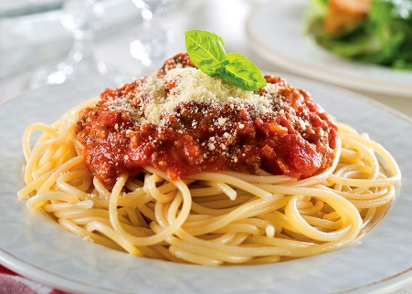


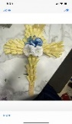

Easter Flowers
We will be selling Easter Flowers this year. All proceeds will go to the Choir fund to help support their portion of the church budget. Please return order forms to the church office by no later than Sunday March 22, 2026. Thank you for your continued support. We can’t guarantee you will receive the colors. We will do our best to accommodate you.
TULIPS
POT SIZE RED YELLOW PURPLE PINK WHITE PRICE PER ITEM X NUMBER ORDERED=TOTAL PRICE
4 ½” ____ ____ ____ ____ ____ $8.00 #____ $______
6” ____ ____ ____ ____ ____ $12.00 #____ $______
HYACINTHUS
POT SIZ YELLOW PURPLE PINK WHITE PRICE PER ITEM X NUMBER ORDERED=TOTAL
4 ½” ____ ____ ____ ____ $8.00 #____ $____
6” ____ ____ ____ ____ $12.00 #____ $____
DAFFODILS
POT SIZE YELLOW PRICE PER ITEM X NUMBER ORDERED=TOTAL TALLY SHEET Name:________________
4 ½” ____ $8.00 #____ $______ Tulips $_____ Phone:________________
6” ____ $12.00 #____ $______ Hyacinthus $_____
LILLIES Daffodils $_____
POT SIZE WHITE PRICE PER ITEM X NUMBER ORDERED=TOTAL Lillies $_____
6” ____ $13.00 #____ $______ Palm Cross $_____
TOTAL COST $_____
PALM CROSSES PRICE PER ITEM X NUMBER ORDERED=TOTAL
Palm Cross $15.00 #______ $______

