Weekly Up-date
May 22, 2026
First Presbyterian Church of Washington website:
www.washingtonfpc.org
New or updated announcements are highlighted.
Sunday Worship 10:30 am

COMMUNION: For the month of June Communion will be held on the 14th of June instead of the 7th.

FATHER’S Day: The Choir is sponsoring a special Father’s Day Bulletin dedicated to all the women in our lives: fathers, grandfathers, uncles, brothers, great grandfathers, godfathers, husbands or special friends. Donation: $2 per name. Fill out the form below and return to the church office by June 14, 2026.Please print clearly. Questions may be directed to Kerri Caldaro at 908-689-2547 office@washingtonfpc.com take your check out to First Presbyterian Church and earmark it “Father’s Day.” (see flyer below)
CLOTHING SHED: Great news. We have a brand-new clothing shed at the far end of the side parking lot. Gather your unwanted wardrobe and donate it in our shed to help raise money for our church. It’s time to switch over your closets with your winter wardrobe. Thanks in advance for your help. Spread the Word.
Friday 5/22/2026 | Facebook Devotions 8:30 am
Sunday 05/24/2026 | NO Church School/NO Bible Study/Worship/Facebook Live 10:30 am
Tuesday 05/26/2026 | Facebook Devotions 8:30 am
Wednesday 5/27/2026 | Facebook Devotions 8:30am/Chancel 7:00pm-7:45pm
Thursday 5/28/2026 | Facebook Devotions 8:30 am/Session-Deacon’s Joint meeting 7pm
Friday 5/29/2026 | Facebook Devotions 8:30 am
Sunday 5/31/2026 | Church School 9:00 am/Bible Study 9:00am/Worship/Facebook Live 10:30 am

CHURCH MEMBER INFORMATION
PANTRY NEEDS: We are now taking NONPERISHABLE donations during office hours
Tuesday-Friday 9-3. Please ring the bell so Kerri can meet you to get your items. Thank you!.

WEEKLY EVENTS AND PROGRAMS
Church School – Sunday mornings at 9:00 am, in the Christian Ed Wing.
Adult Groups-9:00 am in the Parlor, led by John Boreman
Wednesday Carillonaires 7:00 pm-7:45 pm,
Chancel Choir 7:45pm-8:45 pm
Fellowship Time - Sunday 10:00 am before Worship Service in the coffee room (sponsored by the Deacon’s
Nedles & Pins Group. 1st Saturday of the month, 10-12 in the parlor. Join us to work on needlecrafts,

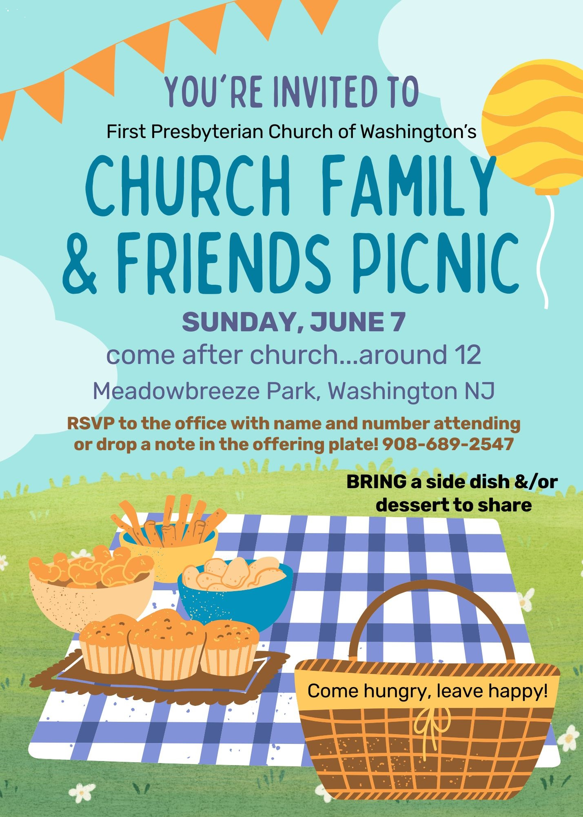



SPECIAL FATHER’S DAY BULLETIN
The Choir is sponsoring a special Father’s Day Bulletin dedicated to all the women in our lives: fathers, grandfathers, uncles, brothers, great grandfathers, godfathers, husbands or special friends. Donation: $2 per name.
Fill out the form below and return to the church office by June 14, 2026. Please print clearly. Questions may be directed to Kerri Caldaro at 908-689-2547 office@washingtonfpc.com take your check out to
First Presbyterian Church and earmark it “Father’s Day.”

HONOR OF:
Name: | Relationship (father, grandfather, etc.) | Given By:

MEMORY OF:
Name: | Relationship (father, grandfather, etc.) | Given By:

