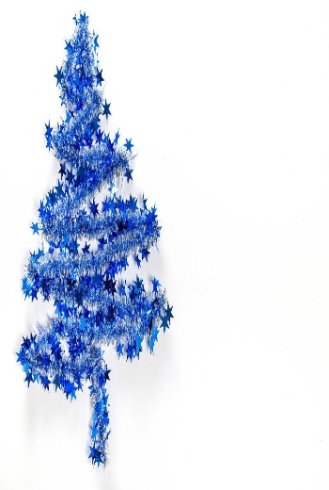
This Photo by Unknown Author is licensed under CC BY
BLUE CHRISTMAS

A time of reflection through music, readings and prayers

Tuesday, December 23
11:00 a.m. in the sanctuary

Followed by BYO lunch

Join Julie Stevenson for a time where we can acknowledge the “blue” feelings at Christmas time. For many who have lost a loved one, this is a time of sharp loneliness. For others, who have lost a relationship, health, a job, or had a financial setback it may be a time of pain, confusion, or fear. This is not a joyous season for everyone.

